Stage 0 Prepare Equipment

- Go to https://portal.azure.com. You will be prompted to sign in. Sign in using your hackathon credentials

- You will see this Azure portals homepage, identify the “Resource Group” that has been created for you for this session. The facilitators will give you the name. If you don’t see the resource group in the “recent” section, search for it on the search bar at the top

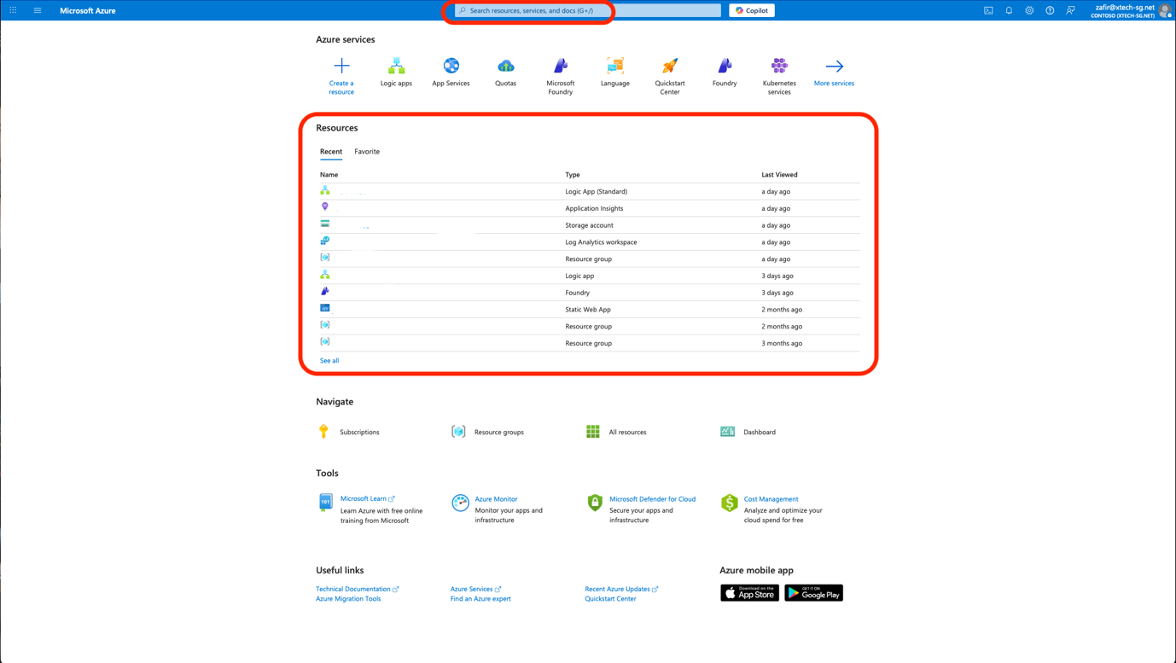

- Now, go to https://ai.azure.com , you should be logged in with the same account you used to log in to Azure portal in step 1.

- This is the page you will see. Congratulations! You have set up all the equipment you need to build Procurement Command Centre!

